Books:
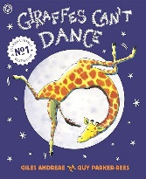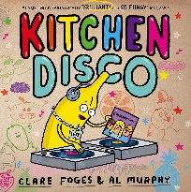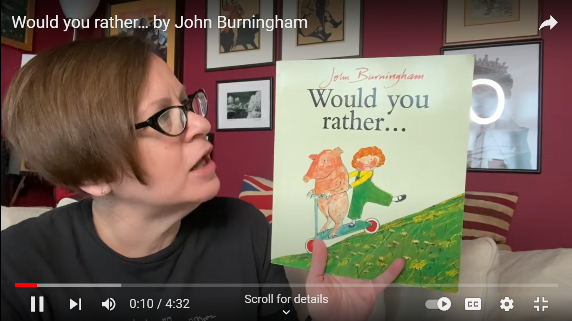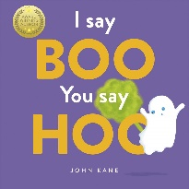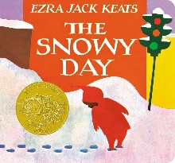
Subject | Focus | Content
Reading | Little Wandle Phonics Scheme Phases 2-5.  Class Stories and ‘The Love of Reading’ | Daily phonics lesson at relevant phase, thrice weekly 1-1 reading session focusing on decoding, prosody and comprehension. Weekly library session. Daily book sharing with whole class.
Writing | Begin to write to communicate (Nelson Handwriting Scheme/Little Wandle letter formation), mark making, form letters and words, writing of name, fine motor skills and writing for a purpose, dough disco | Various opportunities to draw, write, make marks or undertake fine motor development (i.e. jigsaws, threading, developing pencil grip etc.) Writing your name, forming letters and writing some words (with support). Daily Dough Disco practice for fine motor manipulation.
Speaking and Listening | Vocabulary Development: nouns, verbs, adjectives, adverbs, pronouns.  Combining words into short 2/3 word sentences.  Requesting, following/giving instructions, answering & asking questions. | Various opportunities to discuss to use and develop vocabulary through i.e. circle time, classroom activities, guided play, free play etc. Assemblies and performances and whole school events.  Implement the Early Talk Boast Program: Jake & Tizzy’s Books  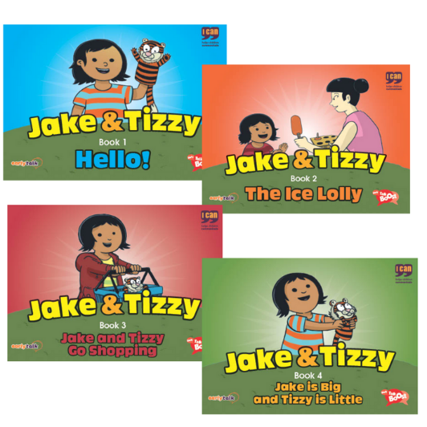
Maths | Number Songs  Counting, Numerals and Value  Sequencing | HG: Number Songs: Related to the above selected texts.  Counting, Numerals and Value: Children continue to subitise up to 5 items and learn to count forwards and backwards to 10 accurately using the counting principles.  The children will use real objects to see that the quantity of a group can be changed by adding more. The first, then, now structure can be used to create mathematical stories in meaningful contexts.  Children continue to count, subitise and compare as they explore one more and one less.  Prompt children to see the link between counting forwards and the one more pattern and back and the one less pattern.  Sequencing: Sequence pictures from a nursery rhyme & sequence pictures from the daily routine.
PSHE | Focus 1: Being Me in My World  Vocabulary: Different, similar, happy, sad, feelings, kind, responsible  Focus 2: Healthy Me  Vocabulary: active, healthy, body parts, hygiene, safe | Focus 1: Being Me in My World  The children will understand how it feels to belong and know people are similar and different. They will understand how feeling happy and sad can be expressed. They will begin to consider other people’s feelings. They will use gentle hands and understand that it is good to be kind to people. They will begin to understand children’s rights and know that this means we should all be allowed to learn and play. They will know what being responsible means.  Focus 2: Healthy Me  They will be able to name some of the parts of their body and will begin to understand that they need to be active to be healthy. They will know what the word ‘healthy’ means and that some foods are healthier than others. They will know some ways to help go to sleep and understand that sleep is important. They will be able to wash their hands and know it is important to do this before they eat and after they go to the toilet. They will know who their safe adults are and how to stay safe if they are not close by them.
Science | Focus: Sorting, categorising and talking about dry materials.  Vocabulary: fabric, dry, cotton, wool, stretchy, furry, silky, smooth | Children will observe a range of fabric materials using a magnifier (e.g. cotton, wool, nylon, hessian, fur, silk).  Encourage them to touch and feel each one in turn. Discuss each one and talk about how they feel e.g. The fur material feels soft and furry. The children sort material into categories e.g. smooth/rough or stretchy/not stretchy.  They will express a preference between the different materials and attempt to make simple representations.  Make a fabric display using different samples of fabric and describing words/symbols around for the children to explore. ‘Is the fabric rough or smooth? Is the fabric silky? Can you find some cotton/woollen fabric? etc.  Fabric Testing: The children will carry out a simple investigation about the strength of different fabrics e.g.- Find out which fabric sample will make the best pair of trousers for Teddy that won’t scuff and tear. Carry out simple test together by wrapping sample of fabric around a block and get children to rub across hard surface (floor/wall). Decide which material is best.
History | Focus: Having Fun - What entertainment did my parents, grandparents and people from Hartlepool enjoy in the past?  Vocabulary: cards, dolls house, radio, dances. theatre | Undertake ‘entertaining activities’ – look at the photos the next day – who is in it, what happened?  Explore and play with old toys.  Look at pictures of children playing with old toys.  Ask parents to send in any toys they have.  Visit places in Hartlepool associated with entertainment in the past – i.e., Mill House, the seafront at Seaton, Hartlepool headland paddling pool, etc.  Watch and answer questions on a Punch and Judy Show (or similar) either live or recorded.  Dance to old music and play old instruments.  Act out an old fayre or carnival.  Watch old cartoons i.e., Tom and Jerry, Bugs Bunny.  Look at the website Hartlepool History Then and Now HHTandN for photos of Hartlepool in past.
Geography | Focus: School Environment  Vocabulary: classroom, school, forwards. Backwards, stop, turn | Children direct other children around school using instructions like ‘forwards, backwards, stop, turn etc.’ to get from one room to another around school.  They interpret simple plans of the classroom, or identify features of the school and local area on online mapping programmes (I.e. Google Maps).  Children attempt to draw maps of i.e. a table or mat with objects on it, or a classroom.  Children look at the school environment, and how they might make it better – i.e. a litter pick, or a display. They undertake whet they’ve decided.
Music | Focus: Disney songs  What are the children’s favourite films? E.g. ‘Bruno from Encanto’, ‘Let it go from Frozen’.  Christmas performance  Instruments: keyboards plus classroom instruments.  Vocabulary: keyboard, press, play, listen, favourite/like/don’t like (symbols) | The children will be able to join in with songs through signing or/and singing. The children will explore keyboards, making their own compositions.  Use symbols or pictures to make a simple composition with support.  Children will request songs through the use of symbols/words/signs  Christmas songs/performance
Art & Design | Focus: Bag Printing  Vocabulary: print, rubbing, stamp, press | Look at the simple artwork patterns of Paul Klee. Can the children recognise any shapes? What may the artist have used to create such pattern in his work? Children to use a variety of materials to stamp and press paint onto a variety of surfaces. Start by using fruit, hands, feet, play objects such as Lego, buttons etc. Can children select a range of coloured paint, can they create patterns? Put various objects/stamps in paint and create artwork/patterns.
PE | Focus: Movement patterns  Vocabulary: move, fast, slow, high, low | Children will follow the actions and movements from stories and songs in the classroom or hall (assemblies).  Carry and explore different sensory equipment such as streamers, parachutes, soft materials, etc.  Engage in games with beanbags, cones, balls and hoops.
Computing | Focus: The children will experience, explore and manipulate a range of technology that is used in their environment; at home, at school and in the community. | The children will have the opportunities to play, explore and activate a range of cause and effect toys with an assortment of mechanisms, participate in active learning and create and think creatively. They will participate in a variety of play-based, unplugged (no computer) activities that focus on building children’s listening skills, curiosity, creativity and problem solving through thoughtful questioning.
RE | Focus: Christmas  Vocabulary: Christmas, Joseph, Mary, Jesus, baby, star | The Saviour of Mankind- Twinkl  The Christmas Story - My First Nativity book  Busy Nativity - Campbell Books  A Very Nosy Christmas - Tim Thornborough  The Christmas Surprise- Steph Williams  Follow the Star - Jesslyn DeBoer  First Festivals Christmas

Date: | Sensory Stories:
Wed 04.09.24 | Would You Rather
09.09.24 | “ “
16.09.24 | Giraffes Can’t Dance
23.09.24 | “ “
30.09.24 | “ “
07.10.24 | “ “
14.10.24 | I Say Boo, You Say Hoo
21.10.24 | “ “
HALF TERM
04.11.24 | Kitchen Disco
11.11.24 | “ “
18.11.24 | “ “
25.11.24 | “ “
02.12.24 | The Snowy Day
09.12.24 | “ “
16.12.24 | “ “
 | BREAK UP FOR CHRISTMAS HOLIDAYS


Upper Glitter Maths

