Books:
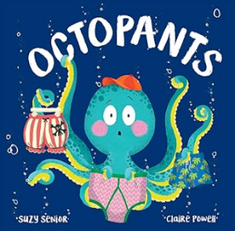
Aliens Love Underpants by C. Freedman, Whatever Next by J. Murphy, Here Come the Aliens by C McNaughton, Goldilocks and the 3 Martians by S. Smith, Octopants by S. Senior, Monsters in Trucks by L. Baker.
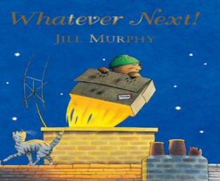
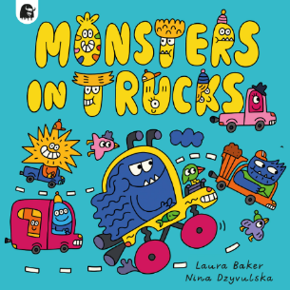
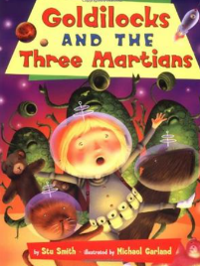
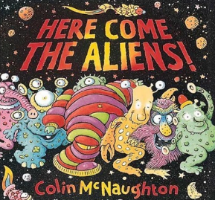
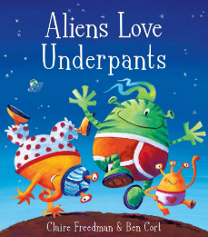

W/B: 05/01/26, 12/01/26 W/B: 19/09/26, 26/01/26 W/B: 02/02/26, 09/02/26 W/B: 16/02/26, 02/03/26 W/B: 09/03/26, 16/03/26 W/B: 23/03/26, 30/03/26
Subject | Focus | Content
Reading | Little Wandle Phonics Scheme Phases 2-5. | Daily phonics lesson at relevant phase, thrice weekly 1-1 reading session focusing on decoding, prosody and comprehension.  Weekly library session.  Daily book sharing with whole class.  Narrative, Poetry, Non-Fiction
Writing | Nelson Handwriting Scheme using Little Wandle letter formation guidance. Writing practice within specific Little Wandle phonics sessions. | Daily specific session and opportunities to apply throughout the day in all lessons.  Using capital letters and full stops and writing with phonic knowledge.  Opportunities for narrative writing linked to class books and topic.
Speaking and Listening | Vocabulary development – topic specific vocab. | Various opportunities to discuss to use and develop vocabulary through i.e. circle time, classroom activities, free play, peer to peer conversations, role play activities, etc including assemblies and performances.  Opportunities to recount experiences and tell stories.
Maths | Alive in 5 Mass and capacity Growing 6,7,8 Length, height and time. Building 9 and 10. Explore 3D shapes. | Introduce 0, Find 0 to 5, Subitise 0 to 5, represent 0 to 5. Compare mass, find a balance, explore capacity, compare capacity. Find 6,7 and 8, 1 more, 1 less. Explore length, compare length, explore height, compare height. Find 9 and 10, Compare numbers to 10, represent 9 and 10, conceptual subitizing to 10. Recognise and name 3D shapes, find 2D shapes within 3D shapes, use 3D shapes for tasks, 3D shapes in the environment.
PSHE | Celebrating Difference | Children will understand key ideas and feelings linked to the following ideas:– proud, special, unique, family, home and friendships.  Children will know how it feels to be proud of something they are good at.  They will know that families are different and that there are lots of different homes.  They will know how they could make new friends.  They will be able to use words to stand up for themselves.
Science | Houses and Homes | Look at and name different types of homes, Bring photographs in of where children live to share, Walk around local area and look at the different types of houses, Build and make models of homes.
History | Inventors: what inventions can I find in my house? | Children will name some present inventions in person and from pictures by verbally stating or matching name/ symbol and picture. Children will answer simple questions about relevant inventions around school using their method of communication – i.e. I see the fridge, I see the phone. They will show some understanding of how interventions were different in the past to now.
Geography | Gardens/ Seasons | Visit allotments and gardens and look at flowers of different colours. Visit places with wildflowers or floral displays. Make an indoor garden, improve the outside environment, discuss preferences. Design a garden map.
Music | I’m walking like a robot -music express  My machine -music express  Instruments -keyboards plus classroom instruments. | Children will be able to join in with songs through signing/singing.  Use symbols or pictures to make a simple composition with support.
Art/DT | Art Textiles /Weaving | Children will be looking at and collecting samples of different types of wool of different colours.  They will explore different materials, using all of their senses to investigate them -use other materials to weave such as straw, plastic bags, variety of papers etc. Children will make simple weaving patterns which express their ideas, using paper strips, shape templates, different materials and then wool. Children will be encouraged to look at patterns in colours and in the weave. We will be looking at the work of Gunta Stölzl and Anni Albers.
PE | Expressive Movements | Children will be encouraged to show interest in dances to music rhymes and songs, imitating movements of others. Children will walk considerable distance with purpose, stopping, starting and changing direction. Children will be able to follow simple instructions when following direction, movements to stories, dancing to songs and considering the way they move.
Computing | Exploring Technology | Children will have the opportunities to explore, experience and manipulate a range of technology that is used in their environment. The children will have the opportunity to play, explore and activate a range of cause and effect toys with an assortment of mechanisms, participate in active learning and think creatively.
RE | Buddhism/Wesak/Vesak Easter | Read religious stories associated with Easter, Buddhism and Wesak/Vesak.  Children will be able to respond to questions linked to relevant activities and stories - particularly on the topics of right and wrong, religious vocabulary, special events, similarities and differences, significant artefacts, symbols or places.  Children will be able to re-tell or act out religious stories.  Children will be communicate simple facts they’ve learned about religion.


