Books: Super Duck, Superheroes Don’t Get Scared, Blow a Kiss Catch a Kiss, We’re Going on a Ghost Hunt, Knock Knock Superhero, A Superpower Like Mine and Snowball.
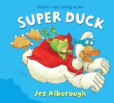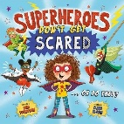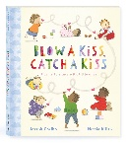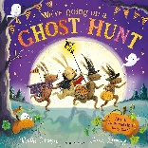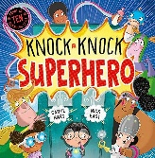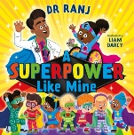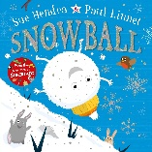
W/B: 7.9.26, 14.9.26 W/B: 21.9.26, 28.9.26 W/B: 5.10.26, 12.10.26 W/B: 19.10.26 W/B: 2.11.26, 9.11.26 W/B: 16.11.26, 23.11.26 W/B: 30.11.26, 7.12.26
Subject | Focus | Content
Reading | Little Wandle Phonics Scheme Phases 2-5. | Daily phonics lesson at relevant phase, thrice weekly 1-1 reading session focusing on decoding, prosody and comprehension. Weekly library session. Daily book sharing with whole class.  Narrative, Poetry.
Writing | Little Wandle Handwriting Scheme using Little Wandle letter formation guidance. Writing practice within specific Little Wandle phonics sessions. | Daily specific session and opportunities to apply throughout the day in all activities – using dough disco,  Using finger spaces, ind. spelling of CVC words and basic tricky words.  Opportunities for narrative writing linked to class books and topic.
Speaking and Listening | Vocabulary development – topic specific vocab. | Various opportunities to discuss to use and develop vocabulary through i.e. circle time, classroom activities, free play, peer to peer conversations. etc. Assemblies and performances. Opportunities to recount experiences and tell stories.
Maths | Match, Sort and Compare  Talk about Measure and Patterns  Its Me 1,2,3  1,2,3,4,5  Circles and Triangles  Shapes with 4 sides | Match objects, match pictures and objects, identify a set, sort objects to a type, explore sorting techniques, create sorting rules, compare amounts.  Compare size, mass and capacity, explore simple patterns, copy and continue simple patterns, create simple patterns.  Find 4 and 5, subitise 4 and 5, represent 4 and 5, 1 more, 1 less, composition of 4 and 5, composition of 1-5.  Identify and name triangles and circles, compare circles and triangles, shapes in the environment, describe position.  Identify and name shapes with 4 sides, combine shapes with 4 sides, shapes in the environment, my day and night.
PSHRE | Being Me in my World | How it feels to belong, people are similar and different, feeling happy and sad, using gentle hands, it’s good to be kind.
Science | My Body and Body Parts | Explore movement, moving through water, moving through sand, moving in different ways, large body movements, small body movements and naming and labeling body parts.
History | My Family are Heroes | Looking at family pictures, recognising and naming family members, specific features of family members, my family home, creating a simple family tree.
Geography | Villages: The Farms and Farmers | Visiting Elwick, Dalton Piercy, Hart, Greatham and Hart, using directional language, what buildings and places can we find? drawing simple maps, looking at crops in September and after harvest, visiting Tweddle Farm and how does it change through the season?
Music | The Superhero Song (Kiboomers) & Christmas Performance. | Joining in with singing, copying actions and learning songs by heart.
Art/DT | Puppets | Explore different puppets through stories and puppet shows, making hand puppets using different types of socks, adding their own embellishments to their puppets.
PE | Kicking at a Target | Shooting at a target and goal, dribbling through cones, racing through cones, moving legs, arms and torso in different ways to build up strength.
Computing | iCan Model/iCan Control | I know the difference between real life and computer models, exploring simple models, be aware that different choices make the computer do different things.  Creating a short sequence of commands for a programmable toy, making predictions about sequences of instructions, making changes to a set of instructions.
RE | Judaism, Yom Kippur, Shabbat, Christmas. | Exploring Jewish music, cookery, dance, food etc., having periods of quietness where children don’t do any ‘work’ (Sabbath), deliver food to those in need.  Sensory nativity story in class, nativity story in church, singing, signing to Christmas hymns, Christmas dinner/ traditional Christmas foods making Christmas decorations for trees in the church, school and/or home.



