The books that we will be focusing on this term include, but are not limited to: -

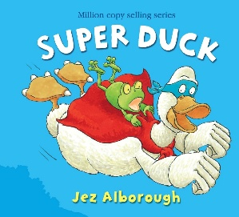 | 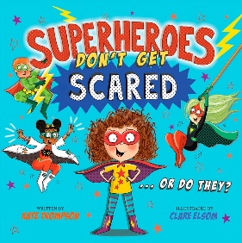 | 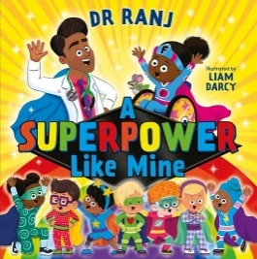 | 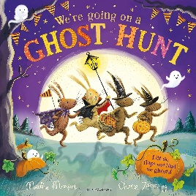 | 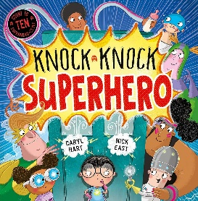 | 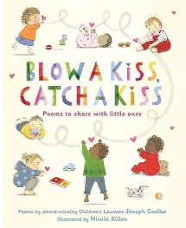 | 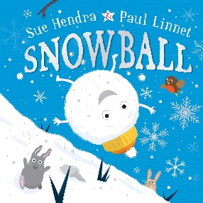
Super Duck  by Jez Alborough | Superheroes Don’t Get Scared  by Kate Thompson | A Superpower Like Mine  by Ranj Singh | We’re Going on a Ghost Hunt  by Martha Mumford | Knock Knock Superhero  by Caryl Hart | Blow a Kiss Catch a Kiss  by Joseph Coelho | Snowball  by Sue Hendra

Week Beginning | Story
7/9/26 | Super Duck
14/9/26 | Super Duck
21/9/26 | Superheroes Don’t Get Scared
28/9/26 | Superheroes Don’t Get Scared
5/10/26 | A Superpower Like Mine
12/10/26 | A Superpower Like Mine
19/10/26 | We’re Going on a Ghost Hunt
2/11/26 | Knock Knock Superhero
9/11/26 | Knock Knock Superhero
16/11/26 | Blow a Kiss Catch a Kiss
23/11/26 | Blow a Kiss Catch a Kiss
30/11/26 | Snowball
7/12/26 | Snowball
14/12/26 | Snowball

Subject | Focus | Content
Reading | Love of Reading  Phonics | Weekly visit to the library to explore and read self-chosen books with an adult and an opportunity to take book home weekly. Opportunities to discuss and develop vocabulary linked to books.  Opportunities daily to access classroom and outdoor reading areas.  Daily opportunity to sing new and familiar songs, including nursery rhymes.  Opportunities for imaginative / narrative / book-based play.  Phase 1 phonics – 5 times a week each morning: listening and remembering sounds, alliteration, rhythm and rhyme  Phase 2 phonics – 5 times a week each morning: letter sounds and letter identification  Reading phonics reading book at least 3 times a week.
Writing | Lower Glitter  Mark making, Overwriting, writing of name, fine motor skills, holding writing utensils.  Upper Glitter  Mark making, letter formation, writing name, fine motor skills, holding writing utensils, independent attempts of writing words | Various opportunities to draw, write, make marks or undertake fine motor development (i.e. jigsaws, threading, dough disco, squiggle while you wiggle, pegs to paper etc…)  Various opportunities to practice letter and word writing. Daily opportunities for dough disco, fine motor activities and ‘Squiggle while you wiggle’, as well as early handwriting activities.
Speaking and Listening | Vocabulary development – Nouns, verbs, adjectives, adverbs, pronouns.  Combining words into short 2/3 word sentences.  Requesting, instructions, asking and answering questions. | Various opportunities to use and develop vocabulary i.e. circle time, classroom activities, guided play, free play etc, assemblies and performances.
Maths | Lower Glitter  Number Songs, real-life maths, colours, counting, numerals, value, weight, representing number, matching, length and height.  Upper Glitter  Number songs, counting, numerals and value, sequencing, length, | Identifying representations of 1, 2 and 3. Subitising and counting to find out how many and making their own collection of 1, 2 or 3 objects. Matching number names to quantities and numerals.  Recognising and naming colours in a variety of contexts.  Making weight comparisons and using balance scales.  Exploring and matching objects which are the same.  Making comparisons and using language to describe length and height.  Subitising up to 5 items and learning to count forwards and backwards to 10 accurately.  Exploring one more and one less.  Sequencing pictures from nursery rhymes, familiar stories and daily routines  Comparing height and length
PSHE | Building Independence | Children will be given time to develop their independence with eating, drinking, dressing and toileting which are all essential life skills. They will be provided with play opportunities, interaction with others and time to process and follow routines and instructions.
Science | Lower Glitter  Exploring the senses  Touch, Taste, Smell, Sound, Sight  Upper Glitter  My body and parts | Children will be able to explore their 5 senses through different multisensory resources and activities. They will be able to answer simple questions (not necessarily verbally) or make simple statements about what they see.  Children will join in with and experience games involving body movements and moving in different ways. They will be able to point to /name the main external parts of their body, and describe what some body parts are used for.
History | Memory, routines and timetables which builds on ‘personal’ history | Children will begin to recognise what is coming up in the daily timetable and be able to look for objects in the correct place in the classroom.  They will begin to remember how and where to hang up coats and other personal items.  Children will begin to show recognition of very recent past events, as well as beginning to communicate about activities and events in the past.
Geography | Villages/The Farms and Farmers (heroes who make our food)/ Seasons | Children will visit various places including exploring villages within the local area and visit places near horse, cow and sheep fields (i.e. Summerhill, North Gare, Home Farm etc.)  They will visit fields to look at crops in September. Then revisit after harvest has taken place.  Children to make visits to Tweddle farm and look at how it changes over the seasons.
Music | Twinkle, Twinkle, Little Star  Christmas performance.  Songs that the class enjoys.  Instruments - shakers / bells | Children will listen to the songs and join in with the actions and rhymes, as well as learn the signs. They will practise singing loudly and quietly.  They will explore a range of shakers, bells and hand bells.  Children will learn Christmas songs and take part in the Christmas performance.
Art/DT | Puppets | Children will explore different puppets within stories and puppet shows. As well as exploring finger puppets.  Where possible, children will experience a theatre which uses puppets and will watch the theatre puppet production of ‘Tales of Acorn Wood’ by Julia Donaldson.  Children will make stick puppets using paper images, drawings or felt material and lollipop sticks.
PE | Kicking | Children will practise kicking with a stationary ball using either foot and experience kicking different balls of different sizes.  They will explore moving and stretching legs when in different spaces and with different outdoor equipment.  Children to take part in rebound activities which emphasise leg movements.
Computing | Lower Glitter | Children will encounter, experience and explore a range of technology that is used in their environment; at home, at school and in the community. Opportunities will be given to play and explore a range of cause-and-effect toys, participate in active learning and begin to create and think creatively.  Children will have opportunities to play with cause-and-effect toys with an assortment of mechanisms.
RE | Judaism/ Yom Kippur/ Rosh Hashanah/Shabbat  Christmas | Children will visit places of significance to Judaism i.e. synagogue, a river or the sea and throw stones (sins) in  They will explore Jewish music, cookery, dance, food etc, as well as Judaism-themed sensory trays.  They will play wind instruments (emulate shofar)  Children will explore Passover by making Seder foods, resources, music and rituals.  Children will take part in a sensory Nativity story in class and in church, as well as sensory play.  They will sing, sign and play along to Christmas hymns.  They will experience Christmas Dinner and traditional Christmas foods.  Children will make Christmas decorations, art and cards.



